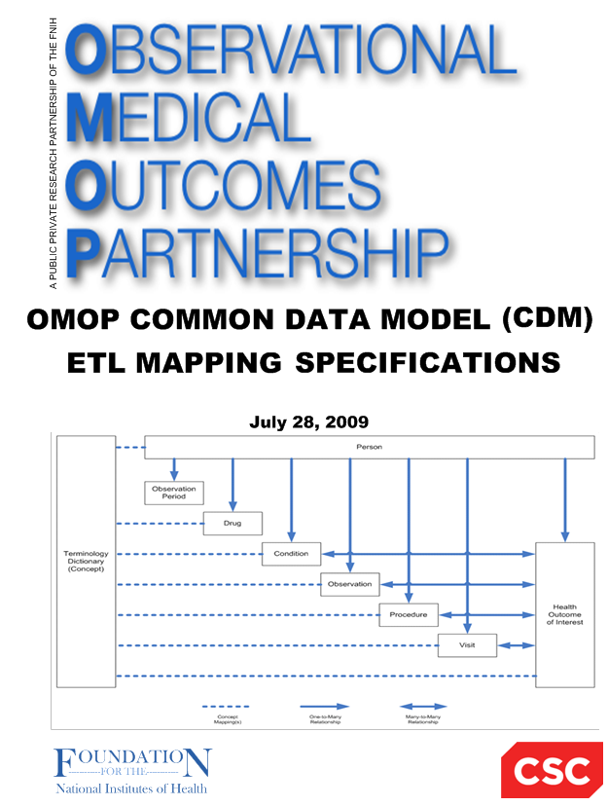

**Japan Medical Data Center (JMDC)**

**to**

**OMOP Common Data Model (CDM V5.0)**

**ETL Mapping Specification**

**Version 4.0**

**25-Feb-2015**

**November 30, 2016**

**Martijn Schuemie**

**Amy Matcho**

**Chris Knoll**

# Contents

1. Contents 2

2. Introduction 3

3. Source Data Mapping Approach 4

4. Data Mapping 6

Table name: person 6

Table name: observation_period 8

Table name: care_site 9

Table name: visit_occurrence 10

Table name: provider 12

Table name: death 15

Table name: condition_occurrence 17

Table name: drug_exposure 20

Table name: procedure_occurrence 23

Table name: measurement 27

Table name: observation 33

Table name: drug_cost 37

Table name: procedure_cost 38

5. Source Independent Data Mapping 39

Table Name: DRUG_ERA 39

Table Name: CONDITION_ERA 39

6. Appendices 40

Drug mapping 40

ICD10 to measurement mapping 41

Specialty mapping 41

Measurement mapping 41

# Introduction

This document reflects the requirements, assumptions, business rules and transformations for the Japan Medical Data Center (JMDC) implementation of the Common Data Model Version 5.0 (CDM) as implemented by Janssen.

The purpose of this document is to describe the ETL mapping of the licensed data from JMDC into the OMOP Common Data Model.

Japanese universal multi-payer health-care system covering virtually all citizens was started in 1961. Currently, there are more than 3000 insurers in Japan which may be divided into several main groups. The government‐managed health insurance (kyo-kai-kenpo) consisting of a single (largest) insurer (central government) covers about 35 million people who are workers in small and medium-size enterprises and their dependents. Area-basis public health insurances (koku-min-ken-ko-ho-ken) run by 1,881 municipal governments (e.g., cities, towns and villages) cover 38 million people. Eighty five cooperative insurances (kyo-sai-kumi-a-i) cover 9 million who are mainly civil servants and their dependents. A total of 1,431 Society-Managed Health Insurances (kumi-a-i-sho-kan-ken-ko-ho-ken) cover 29 million who are workers in relatively large enterprises and their dependents. A new scheme starting from 2008 called as “Medical Care System for People Aged 75 and over” run by 47 prefectures covers 15 million old people aged 75 or older.

JMDC database consists of data from 60 Society-Managed Health Insurances covering workers aged 18 to 65 and their dependents (children younger than 18 years old and elderly people older than 65 years old). The old people (particularly those aged 66 or older) are less representative as compared with whole population in the nation. When estimated among the people who are younger than 66 years old, the proportion of children younger than 18 years old in JMDC is approximately the same as the proportion in the whole nation. JMDC data includes data on membership status of the insured people and claims data provided by insurers under contract. Claims data are derived from monthly claims issued by clinics, hospitals and community pharmacies. The number of claims issued and added to JMDC database is about 800,000 per month. The size of JMDC population is 1.9 million, 1.5% of about 120 million people in the whole nation. A total of 60 insurances may be classified by data period as follows:

<data period> <N of insurances> <Start year>

10 years 4 2005

7 years 5 2008

6 years 16 2009

5 years 7 2010

4 years 11 2009 or 2011

3 years 7 2009 or 2012

2 years 4 2009 to 2013

1 year 5 2009 (one year)

This document is based on the OMOP ETL Specifications. General information that is covered by the OMOP ETL Specification will not be covered in this document, but a detailed discussion of the JMDC specific aspects of mapping and converting data to the standard CDM is provided.

The document is composed of two main sections:

* Source Data Mapping. Describes major tables of the CDM schema and special data handling required for each table.
* Source Independent Data Mapping. Describes mapping process of the Drug and Condition Era’s..

In each section, the tables and their mapping are individually reviewed along with any source specific rules and exceptions.

The intended audience for this document will include both researchers that want to use the experience and learning in order to incorporate them into their own CDM construction.

# Source Data Mapping Approach

The figure below represents the general approach to mapping the source data tables that are available in JMDC to the CDM data schema. The orange boxes represent the input tables in JMDC and the blue boxes represent the resulting CDM tables.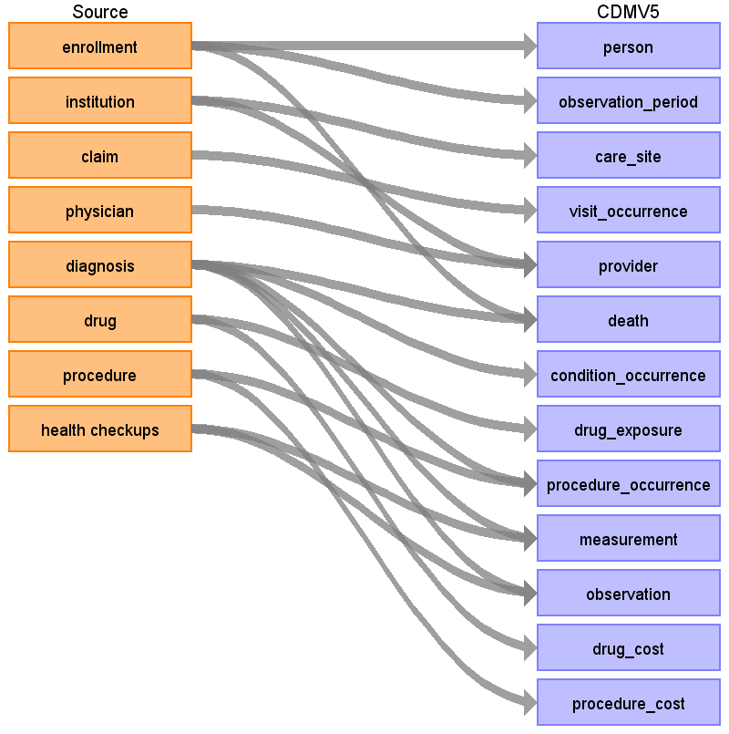

# Data Mapping

## Table name: person

Reading from enrollment

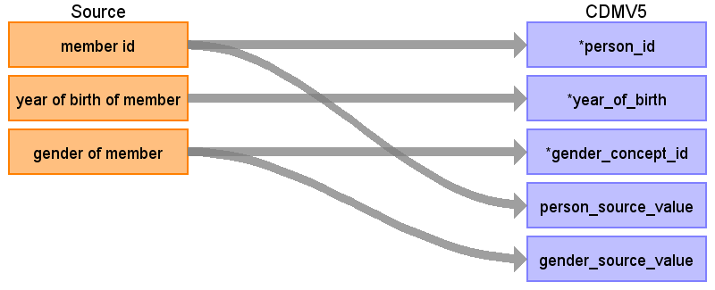

|  |  |  |  |
| --- | --- | --- | --- |
| Destination Field | Source Field | Logic | Comment |
| person_id | member id | Remove ‘M’ prefix |  |
| year_of_birth | year of birth of member |  |  |
| gender_concept_id | gender of member | male = 8507 female = 8532 |  |
| month_of_birth |  |  |  |
| day_of_birth |  |  |  |
| time_of_birth |  |  |  |
| race_concept_id |  |  |  |
| ethnicity_concept_id |  |  |  |
| location_id |  |  |  |
| provider_id |  |  |  |
| care_site_id |  |  |  |
| person_source_value | member id |  |  |
| gender_source_value | gender of member |  |  |
| gender_source_concept_id |  |  |  |
| race_source_value |  |  |  |
| race_source_concept_id |  |  |  |
| ethnicity_source_value |  |  |  |
| ethnicity_source_concept_id |  |  |  |

## Table name: observation_period

Observation period start date is the max of ‘month and year of entry’ field for the patient and the first claim date for all patients in the claim file. Observation period end date is the min of the ‘month and year of withdrawal’ for the patient and the last claim date found in the claim file for all patients. Delete any patients without observation time (observation period end date-observation period start date<=0).

Reading from enrollment

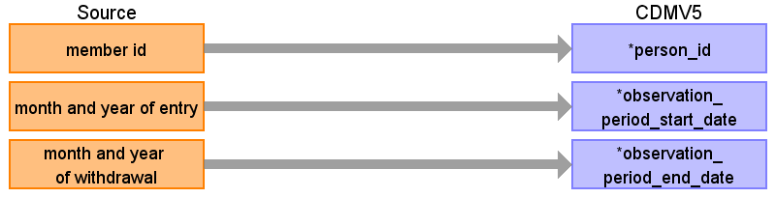

|  |  |  |  |
| --- | --- | --- | --- |
| Destination Field | Source Field | Logic | Comment |
| observation_period_id |  |  | Autogenerate |
| person_id | member id | Remove ‘M’ prefix |  |
| observation_period_start_date | month and year of entry | Take the max of month and year of entry, and the database start month. Database start month can be found using: SELECT MIN([Month and year of medical care]) FROM [Claim]. Set date to 1st of the month. |  |
| observation_period_end_date | month and year of withdrawal | Take the min of month and year of withdrawal, and the database end month. Database end month can be found using: SELECT MAX([Month and year of medical care]) FROM [Claim]. Set date to end of selected month. |  |
| period_type_concept_id |  |  |  |

## Table name: care_site

Reading from institution

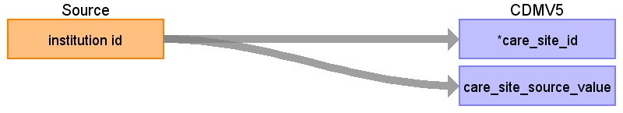

|  |  |  |  |
| --- | --- | --- | --- |
| Destination Field | Source Field | Logic | Comment |
| care_site_id | institution id | Replace ‘F’ prefix with ‘1’ |  |
| care_site_name |  |  |  |
| place_of_service_concept_id |  |  |  |
| location_id |  |  |  |
| care_site_source_value | institution id |  |  |
| place_of_service_source_value |  |  |  |

## Table name: visit_occurrence

Each unique claim id for a patient will be assigned to a visit, **except for pharmacy claims**. In claims only the year + month is provided, day information is not available. However, oftentimes a claim will be associated with a piece of information that does have a specific date. Specific dates can come from prescription date, procedure date, admission date, discharge date, or the start of medical care date. This information will be used to infer the visit date with more precision. (e.g. if it’s a 2 day visit, and it has a procedure taking place on the 20th, we might assume the visit starts on the 20th). If no specific date is available, we will assume the visit start and any events associated with the visit fall on the 15th of the month. We choose the middle of the month because accidental reversal of temporality (where the order of events is switched because one piece of information did have a date, and another didn’t) is just as likely to occur in one direction as the other.

Reading from claim

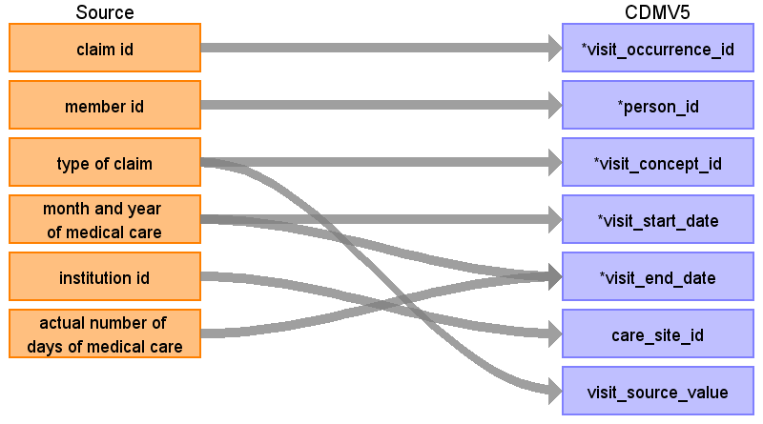

|  |  |  |  |
| --- | --- | --- | --- |
| Destination Field | Source Field | Logic | Comment |
| visit_occurrence_id | claim id | Remove ‘C’ prefix |  |
| person_id | member id | Remove ‘M’ prefix |  |
| visit_concept_id | type of claim | DPC and inpatient 9201 Outpatient and Pharmacy 9202 |  |
| visit_start_date | month and year of medical care | If a claim is associated with a Diagnosis that has an admission date, set the visit_start_date to the max of the admission date and the first of the month of medical care.  If the claim is associated with a Drug.[Prescription date] or Procedure.[Procedure date], use the minimum of those dates as the visit_start_date.  If the claim is associated with a diagnosis, and (1) that [Diagnosis].[Month and year of start of medical care] date falls within the [Month and year of medical care] and (2) there is no other diagnoses with the same level 4 ICD-10 code from the same institution for the same member with the same [Month and year of start of medical care] date, then the [Month and year of start of medical care] date is used as the visit_start_date. If multiple dates are found matching these criteria, take the last of these dates.  Else assume the visit started on the 15th of the [month and year of medical care]. |  |
| visit_start_time |  |  |  |
| visit_end_date | month and year of medical care  actual number of days of medical care | Compute as visit_start_date + number of days of medical care |  |
| visit_end_time |  |  |  |
| visit_type_concept_id |  | 44818517 (Visit derived from encounter on claim) |  |
| provider_id |  |  |  |
| care_site_id | institution id | Replace ‘F’ prefix with ‘1’ |  |
| visit_source_value | type of claim |  |  |
| visit_source_concept_id |  |  |  |

## Table name: provider

Reading from institution

We create a dummy provider for every institution, so we can at least capture specialty for diagnoses and procedures (which are mapped to institution, but not to physician).

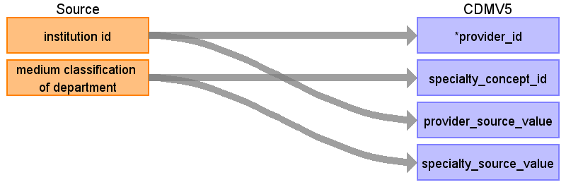

|  |  |  |  |
| --- | --- | --- | --- |
| Destination Field | Source Field | Logic | Comment |
| provider_id | institution id |  | Replace ‘F’ prefix with ‘1’ |
| provider_name |  |  |  |
| npi |  |  |  |
| dea |  |  |  |
| specialty_concept_id | medium classification of department | Use mapping table |  |
| care_site_id |  |  | When mapping from institution, this is the care_site_id corresponding to that institution |
| year_of_birth |  |  |  |
| gender_concept_id |  |  |  |
| provider_source_value | institution id |  |  |
| specialty_source_value | medium classification of department |  |  |
| specialty_source_concept_id |  |  |  |
| gender_source_value |  |  |  |
| gender_source_concept_id |  |  |  |

Reading from physician

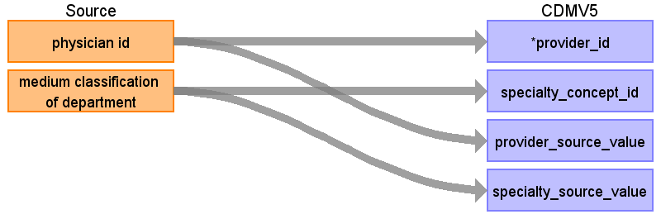

|  |  |  |  |
| --- | --- | --- | --- |
| Destination Field | Source Field | Logic | Comment |
| provider_id | physician id |  | Replace ‘P’ prefix with ‘2’ |
| provider_name |  |  |  |
| npi |  |  |  |
| dea |  |  |  |
| specialty_concept_id | medium classification of department | Use provided mapping |  |
| care_site_id |  |  | When mapping from institution, this is the care_site_id corresponding to that institution |
| year_of_birth |  |  |  |
| gender_concept_id |  |  |  |
| provider_source_value | physician id |  |  |
| specialty_source_value | medium classification of department |  |  |
| specialty_source_concept_id |  |  |  |
| gender_source_value |  |  |  |
| gender_source_concept_id |  |  |  |

## Table name: death

There are two sources of death status: enrollment and the diagnosis table. Death is coded as ‘outcome = 2’ in the diagnosis table, and as ‘death flag = 1’ in the enrollment table. To make sure we have at most one death per person, when there are multiple death records per person, we will take the latest from diagnose if available, else the date from enrollment. The reason for this is that the date from diagnosis might be specific to date, whereas the information from enrollment status is always at the month level and therefore assumed to be at the end of the month.

Reading from diagnosis

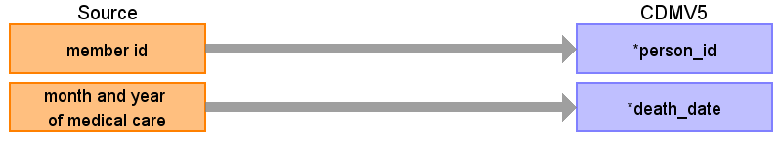

|  |  |  |  |
| --- | --- | --- | --- |
| Destination Field | Source Field | Logic | Comment |
| person_id | member id | Remove ‘M’ prefix |  |
| death_date | month and year of medical care | Use end of visit/claim date |  |
| death_type_concept_id |  |  | From enrollment: 38003565 (Payer enrollment status "Deceased") From diagnosis: 38003567 (Medical claim diagnostic code indicating death) |
| cause_concept_id |  |  |  |
| cause_source_value |  |  |  |
| cause_source_concept_id |  |  |  |

Reading from enrollment

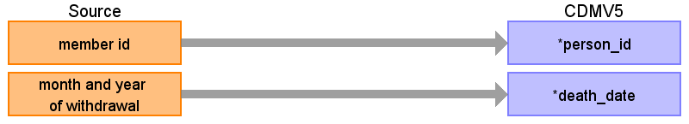

|  |  |  |  |
| --- | --- | --- | --- |
| Destination Field | Source Field | Logic | Comment |
| person_id | member id | Remove ‘M’ prefix |  |
| death_date | month and year of withdrawal | Set death date to last day of [Month and year of withdrawal] |  |
| death_type_concept_id |  |  | From enrollment: 38003565 (Payer enrollment status "Deceased") From diagnosis: 38003567 (Medical claim diagnostic code indicating death) |
| cause_concept_id |  |  |  |
| cause_source_value |  |  |  |
| cause_source_concept_id |  |  |  |

## Table name: condition_occurrence

Two types of conditions will be captured in JMDC: (1) ICD-10 diagnoses with start dates of the associated visit (see visit_occurrence section for how these are determined), and (2) ICD-10 diagnoses with start dates of the ‘month and year of start of medical care’. This second type of condition record can be considered to be a ‘condition era’ type record, as the condition start date will in some cases be the actual start of the condition as opposed to a service date related to the condition. See mapping table below for specific logic.

This condition-era type record is possible because in Japanese claims, the “Month and year of start of medical care” is specified for almost all conditions and is the first day when that hospital/clinic started to provide health-care service for that condition. This date can be very old (e.g., decades ago).

The “Month and year of start of medical care” is often the date of true occurrence of the condition though the date can be later than the true occurrence date as a new start date will be created if the patient is referred to a different clinic/hospital. Even in the same clinic/hospital, a new start date may be given to the same condition of the same patient because of several reasons. For instance, if the patient had an acute condition again after the recovery from the previous same acute condition, a new start date may be created as two episodes were judged independent. Even for the chronic condition, a new start date may be created if the service has not been given for certain period (e.g., more than several months). The latter may occur according to the policy of handling patient’s conditions which may differ between clinics/hospitals. A new start date may also be created from an administrative view (e.g., the service fee for a new condition is a little higher than that for an old condition).

Reading from diagnosis

When an ICD10 code in the diagnosis table maps to a concept in the Condition domain a record should be created in the condition_occurrence table, except when the field ‘Suspicion flag’ equals 1.

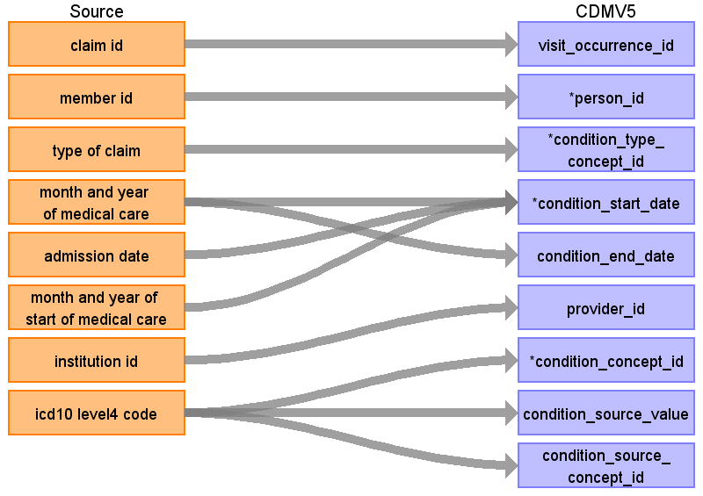

|  |  |  |  |
| --- | --- | --- | --- |
| Destination Field | Source Field | Logic | Comment |
| condition_occurrence_id |  |  | Autogenerate |
| visit_occurrence_id | claim id |  |  |
| person_id | member id | Remove ‘M’ prefix |  |
| condition_type_concept_id | type of claim | out-patient: 38000215 (Outpatient detail - 1st position) in-patient or DPC: 38000184 (Inpatient detail - 1st position)  condition-era type record 38000246 (Condition era - 0 days persistence window) |  |
| condition_start_date | month and year of medical care  month and year of start of medical care  admission date | Use admission date when populated, otherwise use start of visit.  Create additional condition occurrences (condition 'eras') if [Month and year of start of medical care] is earlier than [Month and year of medical care], use [Month and year of start of medical care] as start date . If [Month and year of start of medical care] precedes the observation_period_start date, set to observation_period_start_date. |  |
| condition_end_date | month and year of medical care | For condition era type records, the end date should be the end of the last diagnosis for that patient that has the specific [Month and year of start of medical care], [Institution ID], and [icd10 level4 code], for all other records set to null |  |
| provider_id | institution id | Replace ‘F’ prefix with ‘1’ | Use dummy provider corresponding to the institute |
| condition_concept_id | icd10 level4 code | Use mapping from ICD10 vocabulary to standard concepts. Remove '-' prior to mapping (e.g. 'I50-' should map to 'I50'), and ignore period (e.g. 'I500' should map to 'I50.0') |  |
| condition_source_value | icd10 level4 code |  |  |
| condition_source_concept_id | icd10 level4 code | Find source concept in vocabulary ICD10. Remove '-' prior to mapping (e.g. 'I50-' should map to 'I50'), and ignore period (e.g. 'I500' should map to 'I50.0') |  |
| stop_reason |  |  |  |

## Table name: drug_exposure

Reading from drug

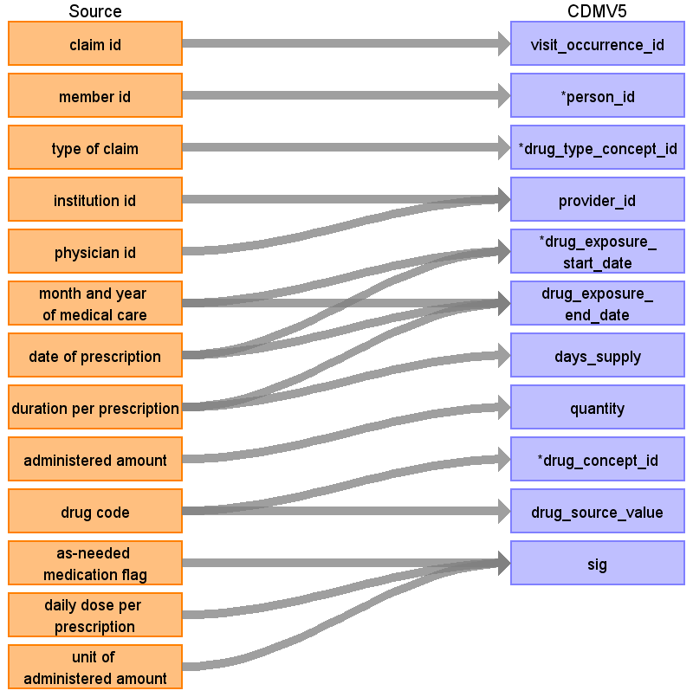

|  |  |  |  |
| --- | --- | --- | --- |
| Destination Field | Source Field | Logic | Comment |
| drug_exposure_id |  |  | Autogenerate |
| visit_occurrence_id | claim id |  |  |
| person_id | member id | Remove ‘M’ prefix |  |
| drug_type_concept_id | type of claim | pharmacy, out-patient: 38000175 (Prescription dispensed in pharmacy) in-patient or DPC: 38000180 (Inpatient administration) |  |
| provider_id | institution id  physician id | If physician is not provided, use the dummy providers we created per institution. Replace ‘F’ or ‘P’ prefix with ‘1’ or ‘2’, respectively. |  |
| drug_exposure_start_date | month and year of medical care  date of prescription | Use date of prescription if available, otherwise set to start of visit. |  |
| drug_exposure_end_date | month and year of medical care  date of prescription  duration per prescription | Drug_exposure_end_date = drug_exposure_start_date + min([Duration per prescription],180) |  |
| days_supply | duration per prescription | If value > 180, set to 180 (occurs in 74 prescriptions) |  |
| quantity | administered amount |  |  |
| drug_concept_id | drug code | Look up in drug mapping table |  |
| drug_source_value | drug code |  |  |
| sig | as-needed medication flag  daily dose per prescription  unit of administered amount | Combine the three fields to create a sig string |  |
| stop_reason |  |  |  |
| refills |  |  |  |
| route_concept_id |  |  |  |
| effective_drug_dose |  |  |  |
| dose_unit_concept_id |  |  |  |
| lot_number |  |  |  |
| drug_source_concept_id |  |  |  |
| route_source_value |  |  |  |
| dose_unit_source_value |  |  |  |

## Table name: procedure_occurrence

Reading from diagnosis

When an ICD10 code in the diagnosis table maps to a concept in the Procedure domain a record should be created in the procedure_occurrence table.

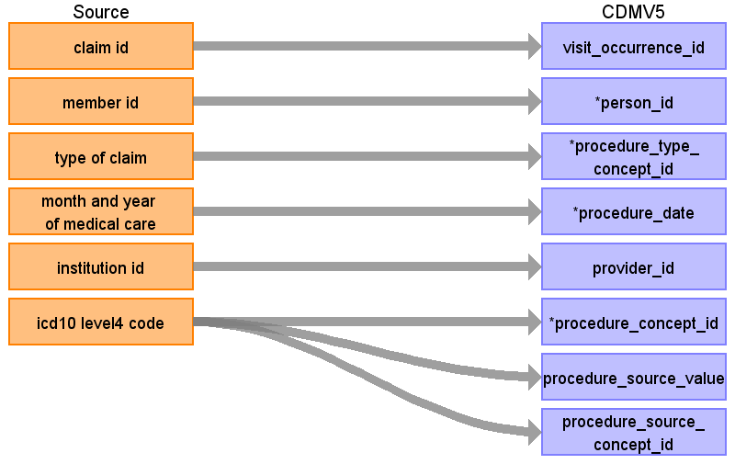

|  |  |  |  |
| --- | --- | --- | --- |
| Destination Field | Source Field | Logic | Comment |
| procedure_occurrence_id |  |  | Autogenerated |
| visit_occurrence_id | claim id |  |  |
| person_id | member id | Remove ‘M’ prefix |  |
| procedure_type_concept_id | type of claim | out-patient: 38000215 (Outpatient detail - 1st position) in-patient or DPC: 38000184 (Inpatient detail - 1st position) |  |
| procedure_date | month and year of medical care | Use admission date when populated, otherwise use start of visit.  Create additional condition occurrences (condition 'eras') if [Month and year of start of medical care] is earlier than [Month and year of medical care]. If [Month and year of start of medical care] indicates a month where there is another diagnosis from the same [Institution ID] with the same [icd10 level4 code], assume that condition 'era' starts on that date. Else assume the start is the 15th of the [Month and year of start of medical care]. If [Month and year of start of medical care] precedes the observation_period_start date, set to observation_period_start_date. |  |
| provider_id | institution id |  | Use dummy provider corresponding to the institute |
| procedure_concept_id | icd10 level4 code | Use mapping from ICD10 vocabulary to standard concepts. Remove '-' prior to mapping (e.g. 'I50-' should map to 'I50'), and ignore period (e.g. 'I500' should map to 'I50.0') |  |
| procedure_source_value | icd10 level4 code |  |  |
| procedure_source_concept_id | icd10 level4 code | Find source concept in vocabulary ICD10. Remove '-' prior to mapping (e.g. 'I50-' should map to 'I50'), and ignore period (e.g. 'I500' should map to 'I50.0') |  |
| modifier_concept_id |  |  |  |
| quantity |  |  |  |
| qualifier_source_value |  |  |  |

Reading from procedure

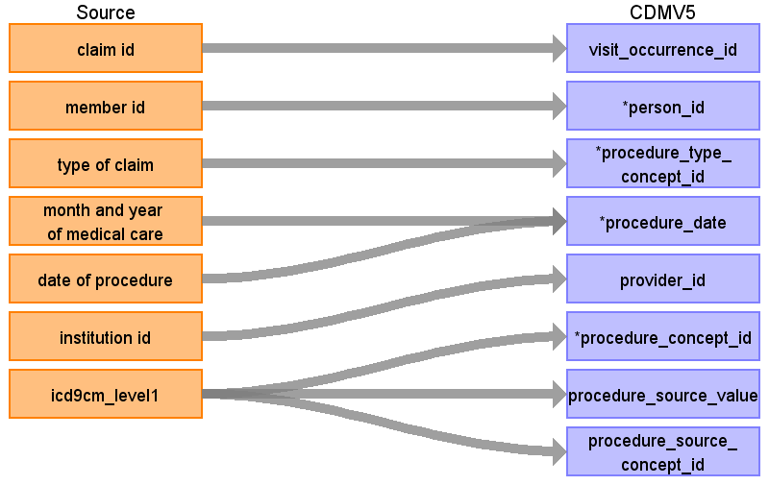

|  |  |  |  |
| --- | --- | --- | --- |
| Destination Field | Source Field | Logic | Comment |
| procedure_occurrence_id |  |  | Autogenerated |
| visit_occurrence_id | claim id |  |  |
| person_id | member id | Remove ‘M’ prefix |  |
| procedure_type_concept_id | type of claim | out-patient: 38000267 (Outpatient detail - 1st position) in-patient or DPC: 38000249 (Inpatient detail - 1st position) |  |
| procedure_date | date of procedure  month and year of medical care | Use date of procedure when populated, otherwise use start of visit |  |
| provider_id | institution id |  | Use the dummy providers we created per institution |
| procedure_concept_id | icd9cm_level1 | Use mapping from vocabulary ICD9Proc to standard concepts. Ignore periods when mapping (e.g. '863' should map to '8.63') |  |
| procedure_source_value | icd9cm_level1 |  |  |
| procedure_source_concept_id | icd9cm_level1 | Find source concepts in vocabulary ICD9Proc. Ignore periods when mapping (e.g. '863' should map to '8.63') |  |
| modifier_concept_id |  |  |  |
| quantity |  |  |  |
| qualifier_source_value |  |  |  |

## Table name: measurement

Reading from diagnosis

When an ICD10 code in the diagnosis table maps to a concept in the Measurement domain a record should be created in the measurement table.

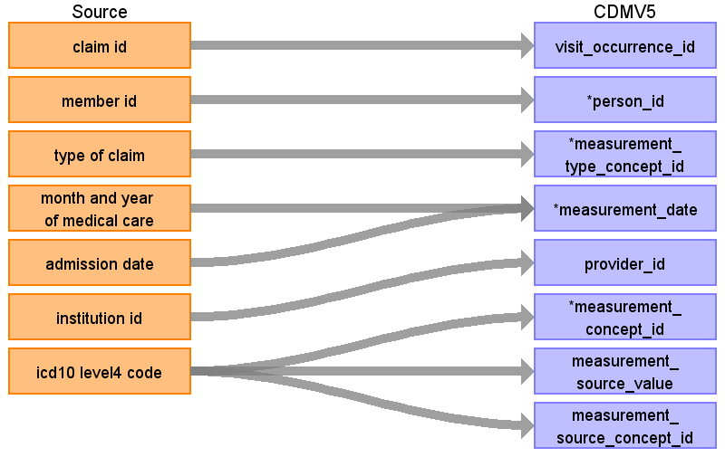

|  |  |  |  |
| --- | --- | --- | --- |
| Destination Field | Source Field | Logic | Comment |
| measurement_id |  |  |  |
| visit_occurrence_id | claim id |  |  |
| person_id | member id | Remove ‘M’ prefix |  |
| measurement_type_concept_id | type of claim | out-patient: 38000215 (Outpatient detail - 1st position) in-patient or DPC: 38000184 (Inpatient detail - 1st position) | 38000277 (Lab observation with numeric result) for continuous fields 38000279 (Lab observation concept code result) for ECG 900000004 (Observation text) for ophthalmoscopies '44814721' (Patient Reported) for Smoking ... |
| measurement_time |  |  |  |
| measurement_date | month and year of medical care  admission date | Use admission date when populated, otherwise use start of visit. |  |
| provider_id | institution id | Use dummy provider corresponding to the institute |  |
| measurement_concept_id | icd10 level4 code | Use mapping from ICD10 vocabulary to standard concepts. Remove '-' prior to mapping (e.g. 'I50-' should map to 'I50'), and ignore period (e.g. 'I500' should map to 'I50.0') | From health checkups: see mapping table |
| measurement_source_value | icd10 level4 code |  |  |
| measurement_source_concept_id | icd10 level4 code | Find source concept in vocabulary ICD10. Remove '-' prior to mapping (e.g. 'I50-' should map to 'I50'), and ignore period (e.g. 'I500' should map to 'I50.0') |  |
| operator_concept_id |  |  |  |
| value_as_number |  |  |  |
| value_source_value |  |  |  |
| value_as_concept_id |  |  | From Health checkups: from mapping table. Else 4181412 (Present) |
| unit_concept_id |  |  | From mapping table |
| unit_source_value |  |  | From mapping table |
| range_low |  |  | From Health checkups: take from reference file |
| range_high |  |  | From Health checkups: take from reference file |

Reading from health checkups

Most information in the health checkups table should be entered in the measurement table.

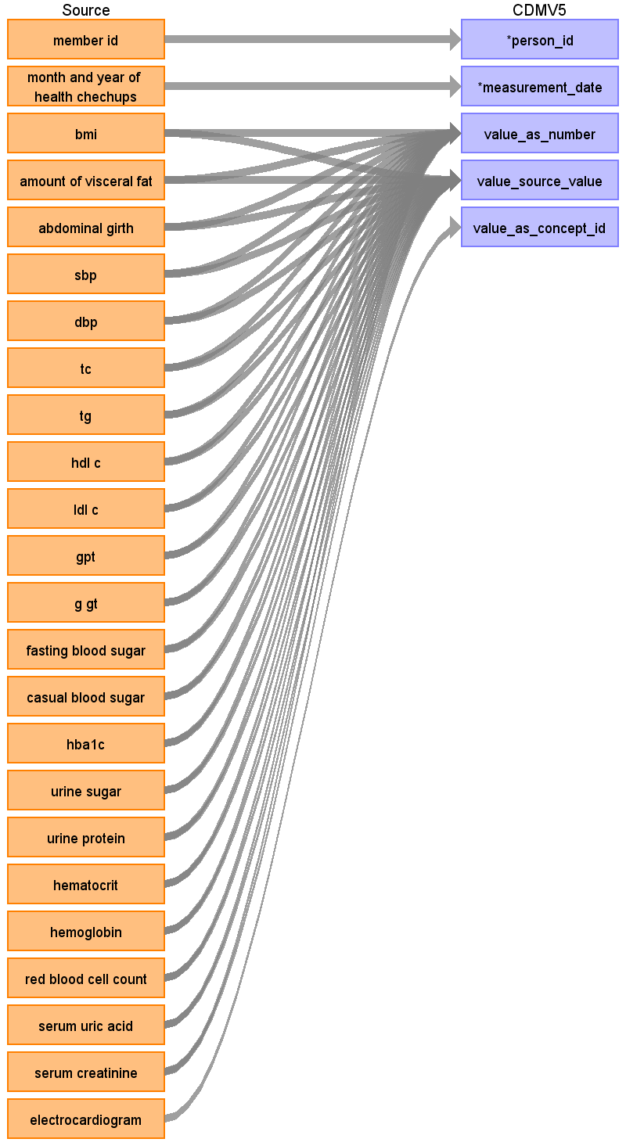

|  |  |  |  |
| --- | --- | --- | --- |
| Destination Field | Source Field | Logic | Comment |
| measurement_id |  |  |  |
| visit_occurrence_id |  |  |  |
| person_id | member id | Remove ‘M’ prefix |  |
| measurement_type_concept_id |  |  | 38000277 (Lab observation with numeric result) for continuous fields 38000279 (Lab observation concept code result) for ECG 900000004 (Observation text) for ophthalmoscopies '44814721' (Patient Reported) for Smoking ... |
| measurement_time |  |  |  |
| measurement_date | month and year of health chechups | Set to 15th of the month |  |
| provider_id |  |  |  |
| measurement_concept_id |  |  | From health checkups: see mapping table |
| measurement_source_value |  |  |  |
| measurement_source_concept_id |  |  |  |
| operator_concept_id |  |  |  |
| value_as_number | bmi  amount of visceral fat  abdominal girth  sbp  dbp  tc  tg  hdl c  ldl c  gpt  g gt  fasting blood sugar  casual blood sugar  hba1c  urine sugar  urine protein  hematocrit  hemoglobin  red blood cell count  serum uric acid  serum creatinine |  |  |
| value_source_value | bmi  amount of visceral fat  abdominal girth  sbp  dbp  tc  tg  hdl c  ldl c  gpt  g gt  fasting blood sugar  casual blood sugar  hba1c  urine sugar  urine protein  hematocrit  hemoglobin  red blood cell count  serum uric acid  serum creatinine |  |  |
| value_as_concept_id | electrocardiogram |  | From Health checkups: from mapping table. Else 4181412 (Present) |
| unit_concept_id |  |  | From mapping table |
| unit_source_value |  |  | From mapping table |
| range_low |  |  | From Health checkups: take from reference file |
| range_high |  |  | From Health checkups: take from reference file |

## Table name: observation

Reading from diagnosis

When an ICD10 code in the diagnosis table maps to a concept in the Observation domain a record should be created in the observation table.

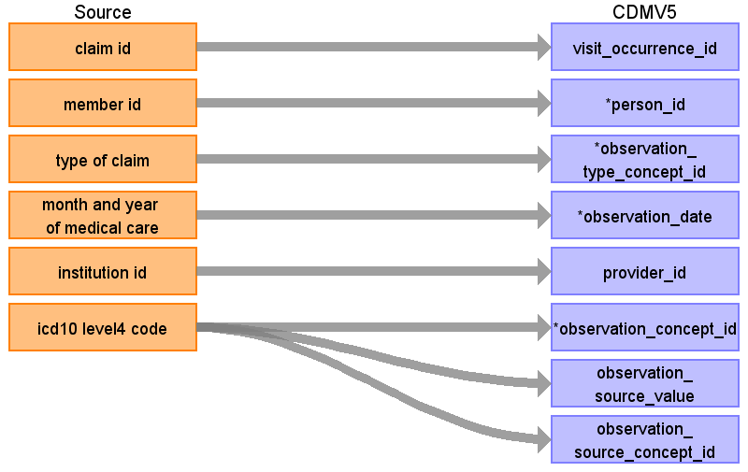

|  |  |  |  |
| --- | --- | --- | --- |
| Destination Field | Source Field | Logic | Comment |
| observation_id |  |  | Autogenerate |
| visit_occurrence_id | claim id |  |  |
| person_id | member id | Remove ‘M’ prefix |  |
| observation_type_concept_id | type of claim | out-patient: 38000215 (Outpatient detail - 1st position) in-patient or DPC: 38000184 (Inpatient detail - 1st position)  condition-era type record 38000246 (Condition era - 0 days persistence window) | From Health Checkups: 44814721 (Patient Reported) |
| observation_date | month and year of medical care | Use admission date when populated, otherwise use start of visit. |  |
| provider_id | institution id |  | Use dummy provider corresponding to the institute |
| observation_concept_id | icd10 level4 code | Use mapping from ICD10 vocabulary to standard concepts. Remove '-' prior to mapping (e.g. 'I50-' should map to 'I50'), and ignore period (e.g. 'I500' should map to 'I50.0') |  |
| observation_source_value | icd10 level4 code |  |  |
| observation_source_concept_id | icd10 level4 code | Find source concept in vocabulary ICD10. Remove '-' prior to mapping (e.g. 'I50-' should map to 'I50'), and ignore period (e.g. 'I500' should map to 'I50.0') |  |
| value_as_concept_id |  |  | From diagnoses:value from “Maps to value” relationship or else 4181412 (present) |
| observation_time |  |  |  |
| value_as_number |  |  |  |
| value_as_string |  |  |  |
| qualifier_concept_id |  |  |  |
| unit_concept_id |  |  |  |
| unit_source_value |  |  |  |
| qualifier_source_value |  |  |  |

Reading from health checkups

Information in the sleeping field should go to the observation table, as well as information in fields that are not mapped to specific concepts.

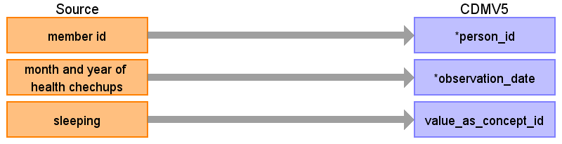

|  |  |  |  |
| --- | --- | --- | --- |
| Destination Field | Source Field | Logic | Comment |
| observation_id |  |  | Autogenerate |
| visit_occurrence_id |  |  |  |
| person_id | member id | Remove ‘M’ prefix |  |
| observation_type_concept_id |  |  | From Health Checkups: 44814721 (Patient Reported) |
| observation_date | month and year of health chechups | Set to 15th of the month |  |
| provider_id |  |  |  |
| observation_concept_id |  |  |  |
| observation_source_value |  |  |  |
| observation_source_concept_id |  |  |  |
| value_as_concept_id | sleeping | 1 = 4188539 (yes), 2 = 4188540 (no) | From diagnoses: 4181412 (present) |
| observation_time |  |  |  |
| value_as_number |  |  |  |
| value_as_string |  |  |  |
| qualifier_concept_id |  |  |  |
| unit_concept_id |  |  |  |
| unit_source_value |  |  |  |
| qualifier_source_value |  |  |  |

## Table name: drug_cost

Reading from drug

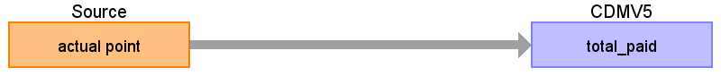

|  |  |  |  |
| --- | --- | --- | --- |
| Destination Field | Source Field | Logic | Comment |
| drug_cost_id |  |  | Autogenerate |
| drug_exposure_id |  |  | Look up in drug_exposure table corresponding to this row in the [Drug] table |
| currency_concept_id |  |  |  |
| paid_copay |  |  |  |
| paid_coinsurance |  |  |  |
| paid_toward_deductible |  |  |  |
| paid_by_payer |  |  |  |
| paid_by_coordination_benefits |  |  |  |
| total_out_of_pocket |  |  |  |
| total_paid | actual point | 1 point = 10 yen |  |
| ingredient_cost |  |  |  |
| dispensing_fee |  |  |  |
| average_wholesale_price |  |  |  |
| payer_plan_period_id |  |  |  |

## Table name: procedure_cost

Reading from procedure



|  |  |  |  |
| --- | --- | --- | --- |
| Destination Field | Source Field | Logic | Comment |
| procedure_cost_id |  |  | Autogenerate |
| procedure_occurrence_id |  |  | Look up in procedure_occurrence table in record corresponding to this row in the [Procedure] table. |
| currency_concept_id |  |  |  |
| paid_copay |  |  |  |
| paid_coinsurance |  |  |  |
| paid_toward_deductible |  |  |  |
| paid_by_payer |  |  |  |
| paid_by_coordination_benefits |  |  |  |
| total_out_of_pocket |  |  |  |
| total_paid | actual point | 1 point = 10 yen |  |
| revenue_code_concept_id |  |  |  |
| payer_plan_period_id |  |  |  |
| revenue_code_source_value |  |  |  |

**Table name: cdm_source**

|  |  |  |  |
| --- | --- | --- | --- |
| Destination Field | Source Field | Logic | Comment |
| cdm_source_name |  | JMDC (Japan Medical Data Center) database |  |
| cdm_source_abbreviation |  | JMDC |  |
| source_description |  | JMDC database consists of data from 60 Society-Managed Health Insurances covering workers aged 18 to 65 and their dependents (children younger than 18 years old and elderly people older than 65 years old). The old people (particularly those aged 66 or older) are less representative as compared with whole population in the nation. When estimated among the people who are younger than 66 years old, the proportion of children younger than 18 years old in JMDC is approximately the same as the proportion in the whole nation. JMDC data includes data on membership status of the insured people and claims data provided by insurers under contract. Claims data are derived from monthly claims issued by clinics, hospitals and community pharmacies. |  |
| source_documentation_reference |  |  |  |
| cdm_etl_reference |  | https://github.com/OHDSI/ETL-CDMBuilder |  |
| cdm_version |  | 5.0.0 |  |

**Table name: cdm_domain_meta**

|  |  |  |
| --- | --- | --- |
| **TABLE NAME** | **DOMAIN_ID** | **DESCRIPTION** |
| PERSON | Person | JMDC covers workers aged 18 to 65 and their dependents (children younger than 18 years old and elderly people older than 65 years old). The old people (particularly those aged 66 or older) are less representative as compared with whole population in the nation. When estimated among the people who are younger than 66 years old, the proportion of children younger than 18 years old in JMDC is approximately the same as the proportion in the whole nation.  Only the year of birth is available, so not the day or month. |
| OBSERVATION_PERIOD | Observation Period | The observation period is defined as the time of enrollment in the health insurance. If the member is a dependent, the enrollment depends on the enrollment of the main beneficiary. |
| CARE_SITE | Care Site | Care sites in JMDC are institutions where care is provided, typically a department in a hospital. |
| VISIT_OCCURRENCE | Visit | Each insurance claim that is not a pharmacy claim is translated into a visit. Because a claim is always for costs in a specific month, a visit is always restricted to one month, even if the underlying real visit is longer than a month. Only the year and month is provided for each claim, day information is not available. However, oftentimes a claim will be associated with a piece of information that does have a specific date. Specific dates can come from prescription date, procedure date, admission date, discharge date, or the start of medical care date. This information will be used to infer the visit date with more precision. (e.g. if it’s a 2 day visit, and it has a procedure taking place on the 20th, we might assume the visit starts on the 20th). If no specific date is available, we will assume the visit start and any events associated with the visit fall on the 15th of the month. We choose the middle of the month because accidental reversal of temporality (where the order of events is switched because one piece of information did have a date, and another didn’t) is just as likely to occur in one direction as the other. |
| PROVIDER | Provider | In JMDC providers are derived from two sources: institutions and physicians. Institutions (typically hospital departments) are included because diagnoses and procedures are linked to institutions but not to physicians, and this way we can preserve the specialty of the department that recorded a diagnosis or procedure. |
| DEATH | Death | There are two sources of death status: enrollment and the diagnosis table. To make sure we have at most one death per person, when there are multiple death records per person, we will take the latest from diagnose if available, else the date from enrollment. The reason for this is that the date from diagnosis might be specific to date, whereas the information from enrollment status is always at the month level and therefore assumed to be at the end of the month. |
| CONDITION_OCCURRENCE | Condition | In JMDC we distinguish between two different types of conditions, both derived from the diagnoses associated with a claim. The first have their start date set to the date of diagnose, which is often taken to be the visit start date. The second type uses the ‘date of start of medical care’ that is recorded for virtually every diagnosis in JMDC. This start date often precedes the actual visit where the diagnosis is recorded, and sometimes even precedes start of enrollment. This second type of conditions is used to construct condition eras by linking diagnoses from the same institution for the same diagnose code with the same start of medical care. |
| PROCEDURE_OCCURRENCE | Procedure | Procedures performed during hospitalization. For procedures the exact day of the procedure (relative to the visit start date) is available. Some of the procedure occurrences are derived from diagnose codes using the vocabulary. |
| DRUG_EXPOSURE | Drug | Drug exposures include a mix of prescriptions and dispensings as records on the insurance claims. |
| MEASUREMENT | Measurement | Most employees in Japan are required by law to undergo annual health checkups. For some but not all insurance companies included in JMDC the results of these checkups are available as measurements. |
| OBSERVATION | Observation | During annual health screenings information about sleeping is collected that cannot go into the measurement table and is therefore stored here. Some observations are derived from some of the diagnosis codes. |

# Source Independent Data Mapping

## Table Name: DRUG_ERA

The DRUG_ERA table is defined as a span of time when a person is assumed to be using a particular drug. Successive periods of such drug exposure may be combined to produce one continuous drug era. The DRUG_ERA table is populated from the DRUG_EXPOSURE table within the CDM. Drug eras are consolidated to their respective ingredient off the DRUG_EXPOSURE table, eliminating all information about strength and administration route. A drug era is therefore understood as exposure to a certain compound over a certain period of time. There will only be one type of persistence window (duration that is allowed to elapse between drug exposures) applied to this CDM, which is 30 days.

| **Destination Field** | **Source Field** | **Applied Rule** | **Comment** |
| --- | --- | --- | --- |
| DRUG_ERA_ID |  | System Generated |  |
| PERSON_ID | PERSON_ID |  |  |
| DRUG_CONCEPT_ID | DRUG_CONCEPT_ID | Do not create DRUG_ERAs where the DRUG_EXPOSURE.DRUG_CONCEPT_ID is 0.  Use the map below to map DRUG_EXPOSURE.DRUG_CONCEPT_ID to the ingredient level DRUG_CONCEPT_ID used in the DRUG_ERA. |  |
| DRUG_ERA_START_DATE | DRUG_EXPOSURE_START_DATE |  |  |
| DRUG_ERA_END_DATE | Drug_exposure_end_date |  |  |
| DRUG_TYPE_CONCEPT_ID |  | Apply a 30 day persistence window and label as CONCEPT_ID 38000182 (Drug era - 30 days persistence window). | Falls under CONCEPT_VOCABULARY_ID = 36 - Drug Exposure Type. |
| DRUG_EXPOSURE_COUNT |  | Sum up the number of DRUG_EXPOSURES for this PERSON_ID and this CONCEPT_ID during the exposure window being built. |  |

## Table Name: CONDITION_ERA

Condition Era table is constructed through an aggregation of individual Condition Occurrences recorded in the CONDITION_OCCURRENCE table.

| **Destination Field** | **Source Field** | **Applied Rule** | **Comment** |
| --- | --- | --- | --- |
| CONDITION_ERA_ID |  | System Generated |  |
| PERSON_ID | PERSON_ID |  |  |
| CONDITION_CONCEPT_ID | CONDITION_CONCEPT_ID | Do not build CONDITION_ERAS where the CONDITION_OCCURRENCE.CONDITION_CONCEPT_ID is 0. |  |
| CONDITION_ERA_START_DATE | CONDITION_START_DATE |  | The start date for the condition era constructed from the individual instances of condition occurrences. It is the start date of the very first chronologically recorded instance of the condition. |
| CONDITION_ERA_END_DATE | CONDITION_END_DATE |  | The end date for the condition era constructed from the individual instances of condition occurrences. It is the end date of the final continuously recorded instance of the condition. |
| CONDITION_TYPE_CONCEPT_ID | - | Apply a 30 day persistence window and label as CONCEPT_ID 38000247 (Condition era - 30 days persistence window). | Falls under CONCEPT_VOCABULARY_ID = 37 - OMOP Condition Occurrence Type. |
| CONDITION_OCCURRENCE_COUNT | - | Sum up the number of CONDITION_OCCURRENCEs for this PERSON_ID and this CONCEPT_ID during the exposure window being built. |  |

# Appendices

## Drug mapping

A drug map was automatically constructed based on the data available in the Drug table. The process is described in this document:



The full mapping can be found here:



## ICD10 to measurement mapping

Some ICD10 codes map to concepts in the Measurement domain. This mapping table provides the value concept IDs:



## Specialty mapping

Specialties were manually mapped from the values of the ‘Medium classification of department’ fields to OMOP Specialty concepts.



## Measurement mapping

Measurements as found in the ‘Health checkups’ table were manually mapped to LOINC concepts, and units were mapped to UCUM concepts.

